ASSIGNMENT : 1
1.
Log in to the AWS Management Console and navigate to the IAM dashboard; take a screenshot of the Users section showing the default view.
ANS :
Steps:

1. Logged in to the AWS Management Console using my AWS account.
2. Searched for IAM (Identity and Access Management) from the AWS Console search bar.
3. Opened the IAM Dashboard.
4. Selected Users from the left-side navigation menu.
5. The Users section displayed the default view and the available IAM users.
6. Captured a screenshot of the Users section for verification.

Screenshot:
IAM → Users section showing the default view
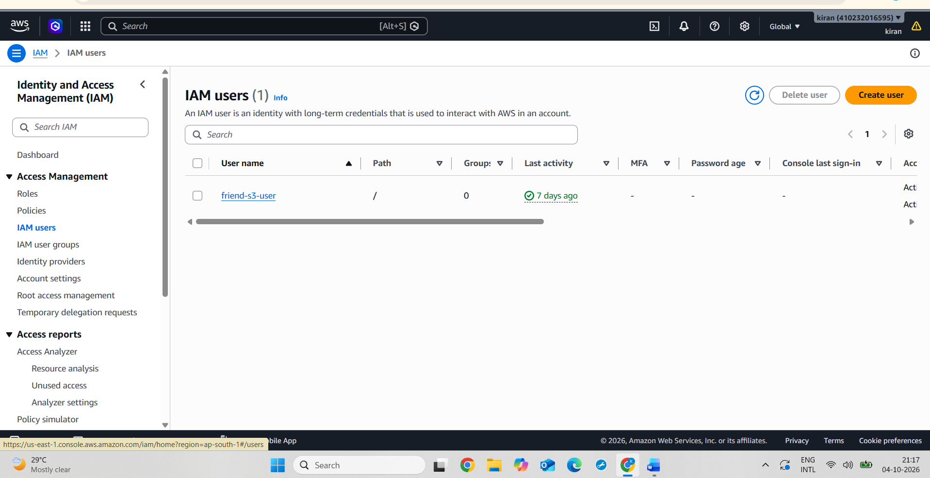
2.
Create a new IAM user named InstaUploader and assign programmatic access only. Download the access key file and note where you saved it.<br><br><em><strong>Hint:</strong> Do not attach any permissions yet—just create the user and save the credentials.</em>
ANS :
Steps:

1. Logged in to the AWS Management Console.
2. Opened IAM (Identity and Access Management).
3. Selected Users from the left navigation menu.
4. Clicked Create users.
5. Created a new IAM user with the username insta-uploader.
6. Did not attach any permissions or policies to the user.
7. Created the IAM user.
8. Opened the Security credentials tab of the "insta-uploader" user.
9. Created an Access Key for programmatic/CLI access.
10. Downloaded the access key credentials file.
11. Saved the credentials file securely in the Downloads folder.
12. No permissions were assigned to the user at this stage.
Screenshot : insta-uploader user successfully created
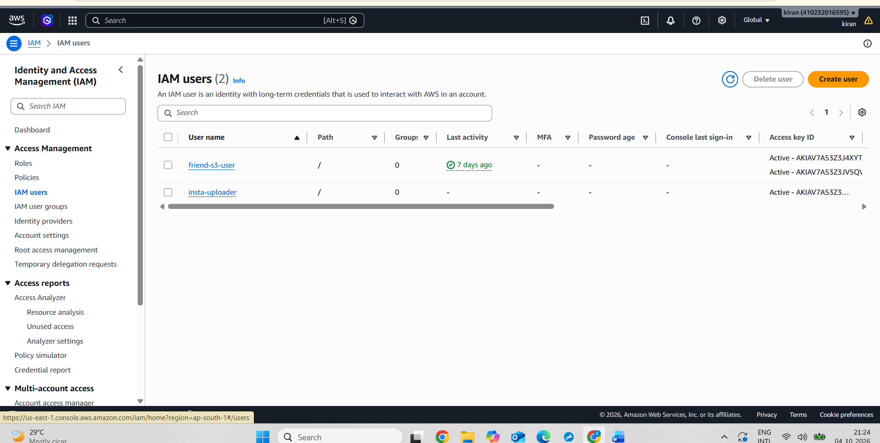
Screenshot : Security credentials page showing the Access keys section for insta-uploader.
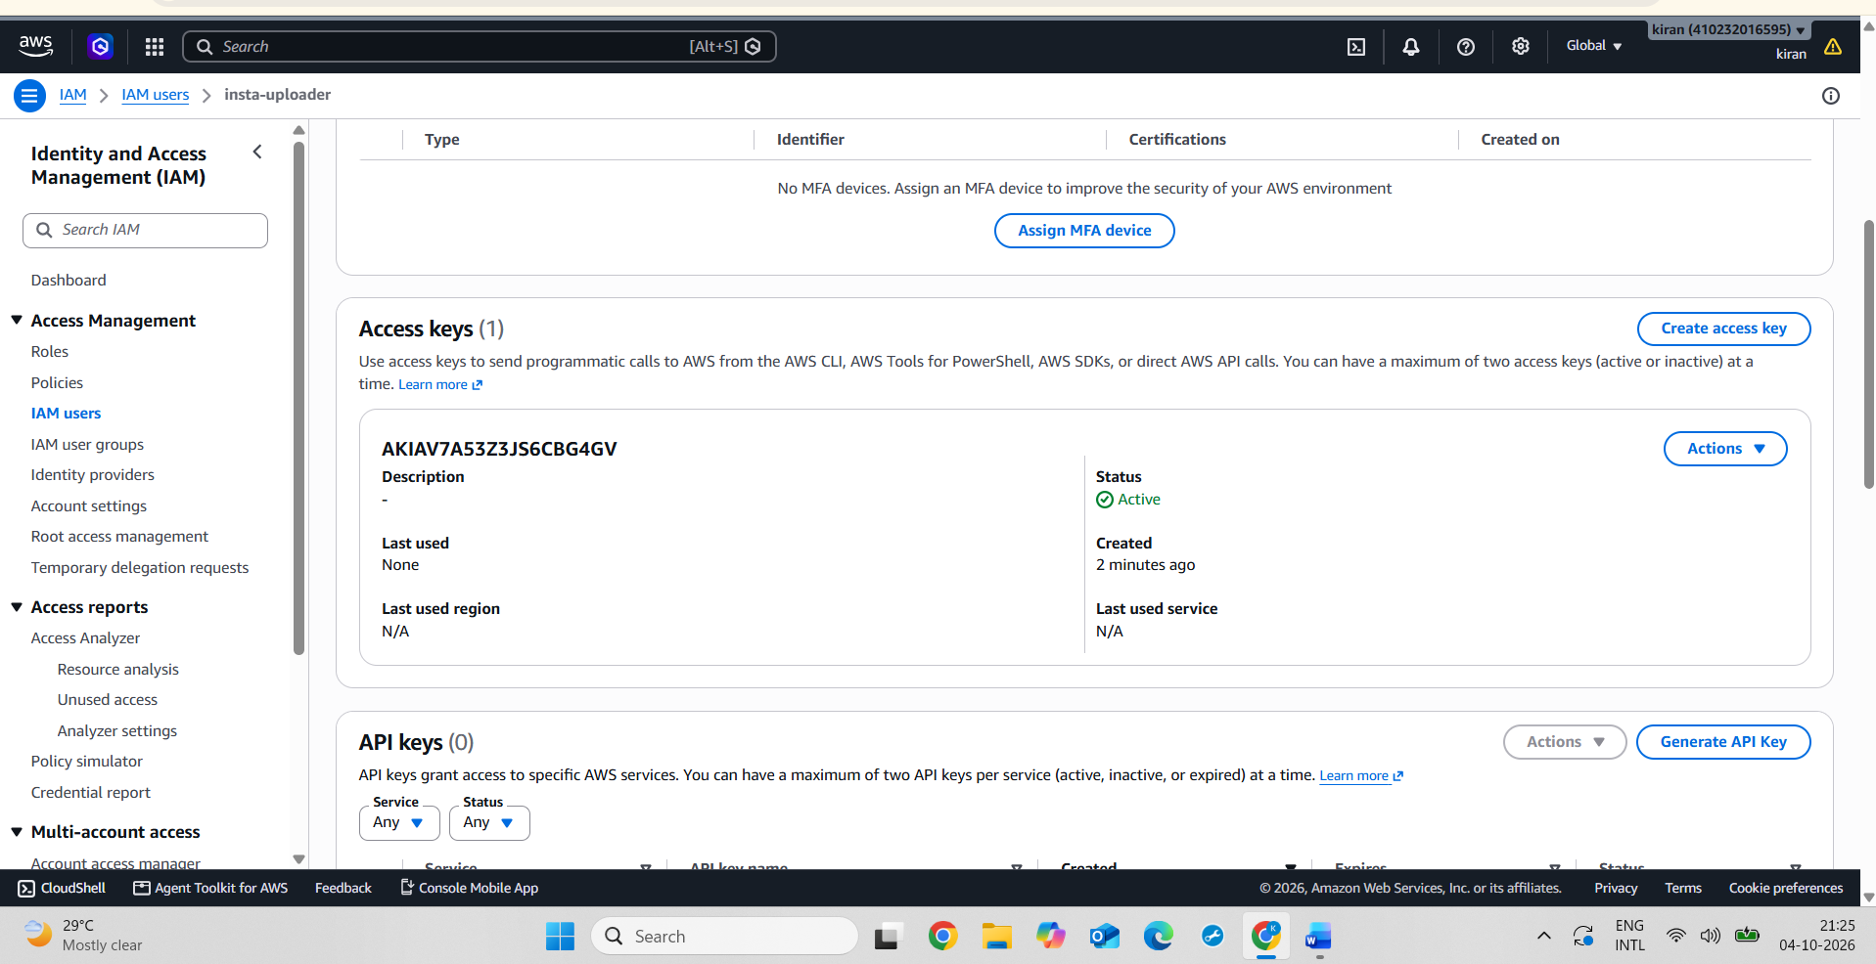
3.
Create a group called ContentCreators in IAM, then add the InstaUploader user to this group.
ANS :
Steps:

1. Logged in to the AWS Management Console.
2. Opened IAM (Identity and Access Management).
3. Selected User groups from the left-side navigation menu.
4. Clicked Create group.
5. Entered content-creators as the group name.
6. Selected the existing IAM user insta-uploader to add to the group.
7. Did not attach any additional permissions to the group.
8. Created the content-creators group.
9. Opened the group and verified that insta-uploader was listed as a group member.
Screenshot:
Content-creators IAM group showing insta-uploader as a group member.
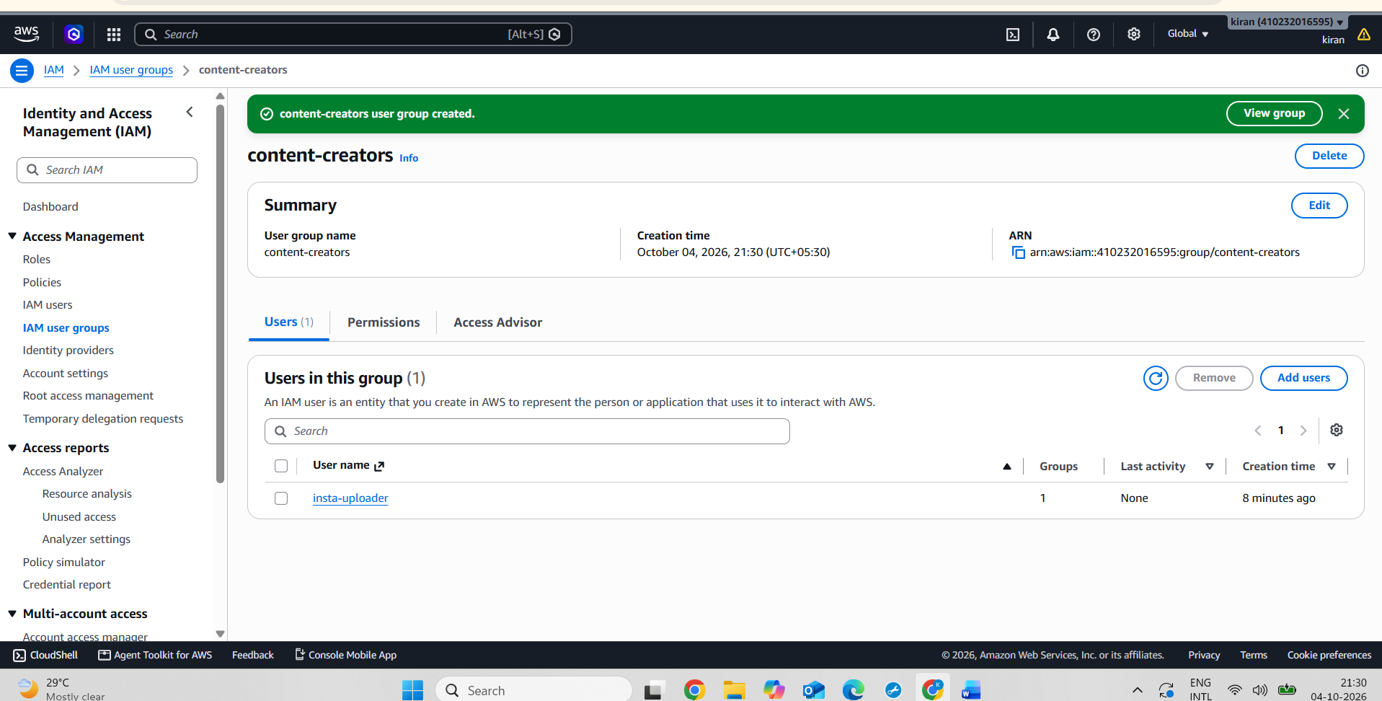
4.
Write a short explanation (3-4 lines) describing the difference between an IAM user and an IAM role, using an example from any app you use daily (e.g., Zomato delivery agent vs. Zomato app admin).
ANS :
An IAM User represents a specific person or application that has permanent credentials, such as an access key or password.
An IAM Role provides temporary permissions that can be assumed by a user or AWS service when needed.
For example, in Zomato, a delivery agent can be compared to an IAM User because they have their own identity and access.
A Zomato app admin/service can be compared to an IAM Role because it can temporarily use specific permissions to perform particular tasks.

